James Lee
CS-255-J7045 System Analysis and Design 23EW5
June 17, 2023
Project Two: Client Presentation Handouts

Slide 1


[No speaker notes required for this slide.]

Slide 2
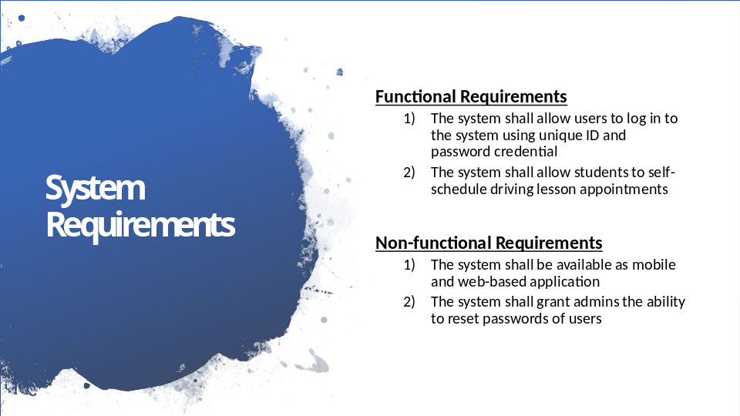
- Some of the functional and non-functional requirements of the DriverPass system are listed here.

FUNCTIONAL REQUIREMENTS
- Functional requirements describe the different functions that the system needs to be able to do. There are many functional requirements for the system; two of these are:
- The ability to log in to the system using unique login credentials, and
- The ability to self-schedule driving lesson reservations by students.

HOW DO THESE REQUIREMENTS MEET DRIVERPASS’S NEEDS?
- Students must be able to log in to the DriverPass system using their unique credential so that they can reserve driving lesson slots themselves.

NON-FUNCTIONAL REQUIREMENTS
- Non-functional requirements are things that the system needs in order to meet the functional requirements, such as operating platform and security considerations. Two of the non-functional requirements of the system are:
- The system shall be available as both mobile and web-based application
- The admins shall be able to change and reset the passwords of users

HOW DO THESE REQUIREMENTS MEET DRIVERPASS’S NEEDS?
- The system must be available on all platforms so that users can access it from any computer or mobile device. The administrators must be able to reset passwords for users who may have forgotten their password or had their password compromised.

Slide 3
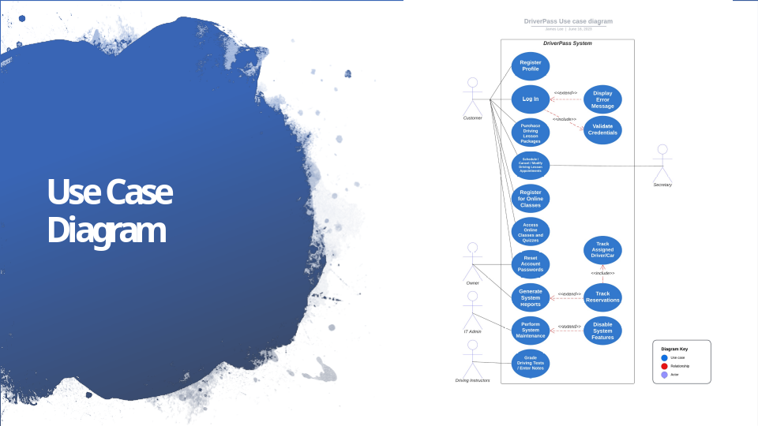
- Who will use the DriverPass system?
- Customers
- Owner
- IT Admin
- Driving Instructors
- Secretary

- The DriverPass system will meet the needs of these users by allowing them to…
- Register Profile
- Log In
- This includes validating the user login credential by the system, and cases when user enters invalid credential, the system displays error message to the user
- Purchase Driving Lesson Packages
- Schedule / Cancel / Modify Driving Lesson Appointments
- Register for Online Classes
- Access Online Classes and Quizzes
- Reset Account Passwords
- Generate System Reports
- The Owner can include reservation summary to the system reports. The reservation summary includes data on drivers and vehicles that are assigned to driving lesson appointments
- Perform System Maintenance
- The IT Admin is able to disable system features while performing system maintenance
- Grade Driving Tests / Enter Notes

Slide 4
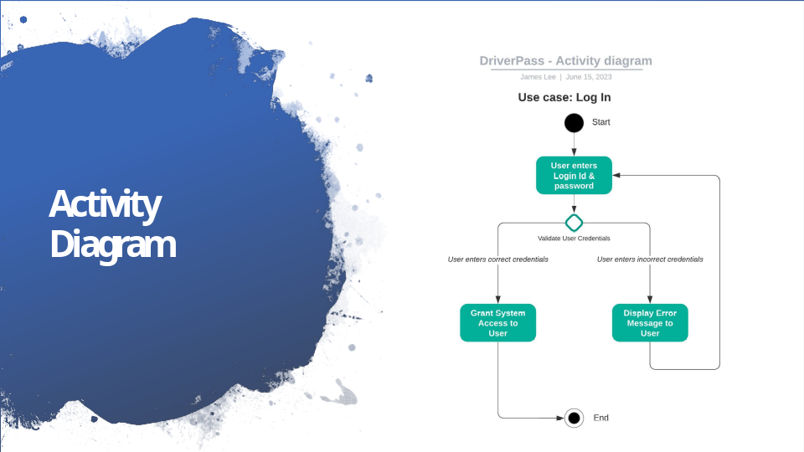

- This diagram depicts a series of actions taken by the DriverPass system when a user logs into the system.

- First, the user provides login ID and password credential.

- The system then validates the user login credential. Here, there are two possible outcomes:
- If the user entered invalid login credential, the system displays error message to the user, then the user is prompted to enter the login credential again.
- Otherwise, if the user entered valid login credential, they are granted access to the system.

- Users must login to the system with their unique login credentials before they are able to use other system functionalities.

Slide 5
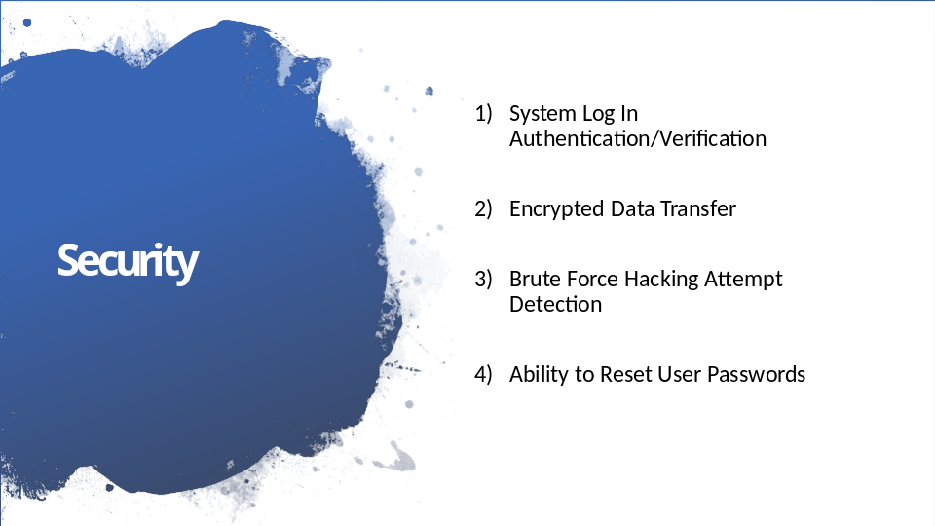

- The DriverPass system incorporates following security measures to keep the system secure:

- Each unique user must first register using unique personal information. Each time the user accesses the system, the user must enter login Id and password. The system then verifies the user and grants access to the user. This ensures that only the authorized users can use the system.

- All user login attempts, as well as payment processes within the system, are encrypted so that these sensitive data are not exposed to unauthorized third party entities.

- The system can detect repeated failed login attempts by any user account and temporarily block login access to that account. The system then alerts the system administrator. This measure helps to prevent unauthorized system access by hackers.

- The system allows users and administrators to reset login passwords. With this, when a user forgets their password, they are able to change their password and access the system, while administrators have the ability to change the password of users in case the password becomes compromised by hackers.

Slide 6
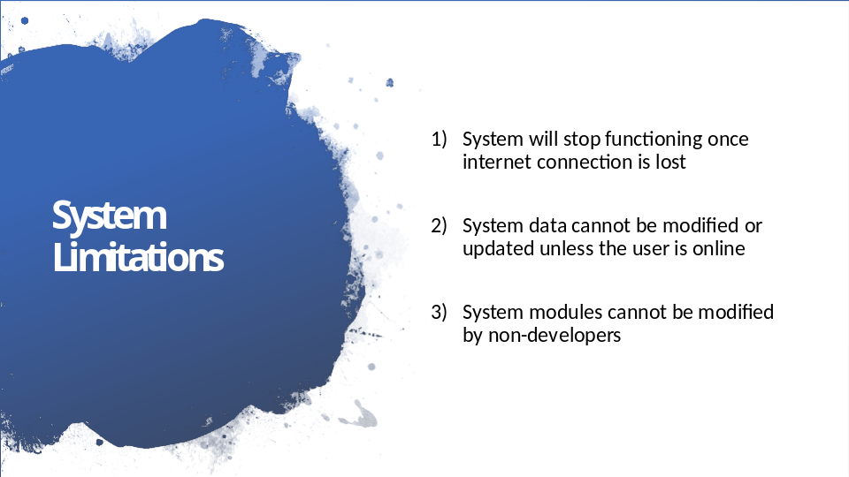

- Because the DriverPass system requires communicating with and accessing the data from the DriverPass server, the user’s device must be connected to the internet to use the DriverPass system.
- In addition, If the device loses connection to the internet while using the system, the system will stop functioning.

- System data can’t be modified or updated unless the user is online. Otherwise, it may cause data to be duplicated on different servers.

- Finally, due to the complex nature of the DriverPass system, adding or removing system features and modules (such as the Driving Lesson Packages offered to the students) requires a developer or a systems analyst.

